Experiment No. – 8
Date of Performance:
Date of Submission:
Program Execution  (06) | Viva  (02) | Professional Ethics  (02) | Experiment  Total (10) | Sign with Date

Experiment No 8

8.1 Aim: Implementation of Predictive Model using Python, Ada-Boosting, Random forests And show Evaluation of Classification Algorithms.

8.2 Course Outcome:
Analyze Machine Learning classification techniques for real world applications.

8.3 Learning Objectives:
Implement predictive models using supervised learning algorithms such as AdaBoost and Random Forests in Python.

8.4 Requirement:
Python 3, Pandas, NumPy, scikit-learn, Seaborn, Matplotlib, Google Colab/Jupyter Notebook, pima-indians-diabetes.csv dataset.

8.5 Related Theory:
Predictive modeling is a vital component of Supervised Machine Learning, where a model is trained using labeled data to make predictions on unseen samples. It involves using classification algorithms to learn the relationship between input features (independent variables) and the output (dependent variable).
In this experiment, we implement Random Forest and AdaBoost (Adaptive Boosting) — two ensemble learning methods — to predict diabetes based on patient health data. We also compare their performance with other traditional algorithms like Logistic Regression, Decision Tree, KNN, Naive Bayes, and SVM.
1. Supervised Learning and Classification
Supervised learning involves training a model on input-output pairs. In classification problems, the goal is to categorize data into predefined classes.
For example, in the Pima Indians Diabetes dataset, the target variable (isdiabetic) represents whether a patient is diabetic (1) or not (0), while input features include glucose level, BMI, age, etc.
2. Ensemble Learning
Ensemble learning combines multiple weak models to create a strong predictive model. Two popular ensemble methods are Bagging and Boosting.
- Bagging (Bootstrap Aggregating):
It trains several base models (like decision trees) independently on random subsets of the dataset and averages their predictions. Random Forest is a prime example of bagging.
- Boosting:
It trains models sequentially, where each model focuses more on the samples misclassified by previous ones. AdaBoost is one of the earliest and most widely used boosting algorithms.
3. Random Forest Algorithm
Random Forest is an ensemble of multiple Decision Trees trained on random subsets of data and features. The final prediction is made through majority voting in classification or averaging in regression.
It reduces overfitting and improves generalization.
Working Steps:
- Select random samples from the dataset.
- Build a decision tree for each sample and get predictions.
- Combine predictions using majority vote.
Advantages:
- Handles large datasets efficiently.
- Robust to outliers and missing data.
- Reduces overfitting compared to a single tree.
Formula:
If T1,T2,...,TnT1​,T2​,...,Tn​ are decision trees,
the final prediction YY is given by:
4. AdaBoost Algorithm (Adaptive Boosting)
AdaBoost combines multiple weak learners (usually shallow decision trees) sequentially. Each new learner focuses more on the data points that were incorrectly classified earlier.
It assigns weights to training samples and updates them in each iteration to minimize errors.
Steps:
- Initialize equal weights for all samples.
- Train a weak model.
- Increase weights for misclassified samples.
- Combine weak learners into a strong model.
Formula:
The final model is a weighted sum of weak classifiers:

where hm(x)hm​(x) = weak classifier,
and αmαm​ = weight of classifier based on its accuracy.
5. Model Evaluation Metrics
- Accuracy:

Measures the proportion of correct predictions.
- Confusion Matrix:
Displays true vs predicted classifications.
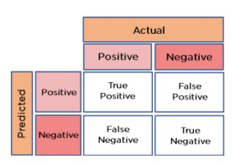
- ROC–AUC Score:
Represents the area under the Receiver Operating Characteristic curve. Higher AUC indicates better model performance.
6. Correlation and Feature Scaling
- Correlation Matrix: Identifies relationships between features and target variable, helping in feature selection.
- Standardization: Ensures all features have equal importance in model training.

- where μμ = mean and σσ = standard deviation.
7. Dataset – Pima Indians Diabetes Dataset
- Contains 768 samples of female patients aged ≥21 years.
- Features include number of pregnancies, glucose level, blood pressure, BMI, insulin, age, etc.
- Target variable: 1 (diabetic), 0 (non-diabetic).
Significance
- Demonstrates real-world prediction using classification algorithms.
- Highlights the importance of preprocessing and feature scaling.
- Shows comparative model performance through accuracy and AUC.
- Reinforces understanding of ensemble learning principles.
8.6 Procedure:
Load the dataset, preprocess it, apply various classification algorithms (including Random Forest and AdaBoost), and evaluate their performance using accuracy and AUC metrics.

8.7 Program and Output:
- Data Loading
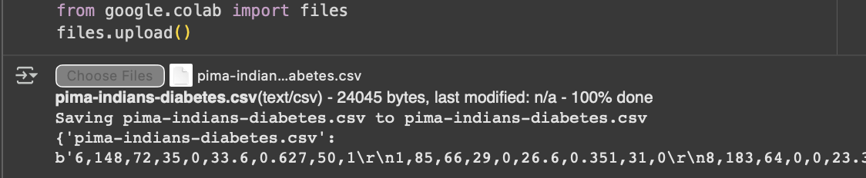
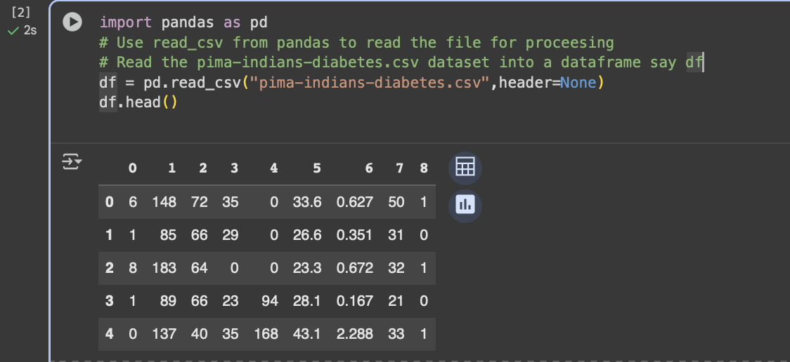

- Perform EDA using following steps
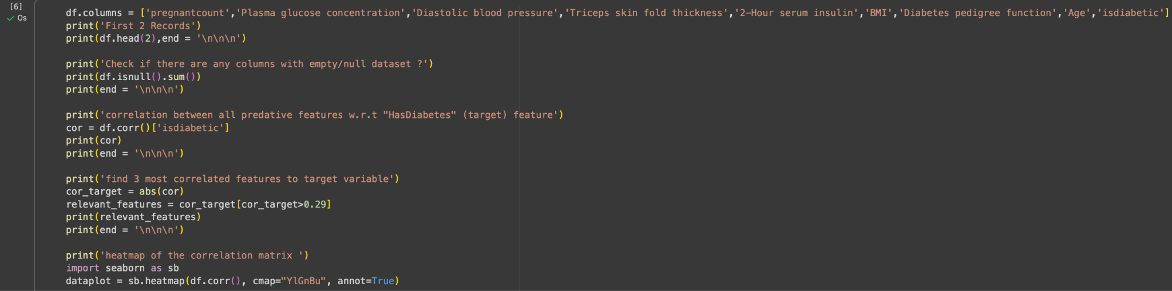
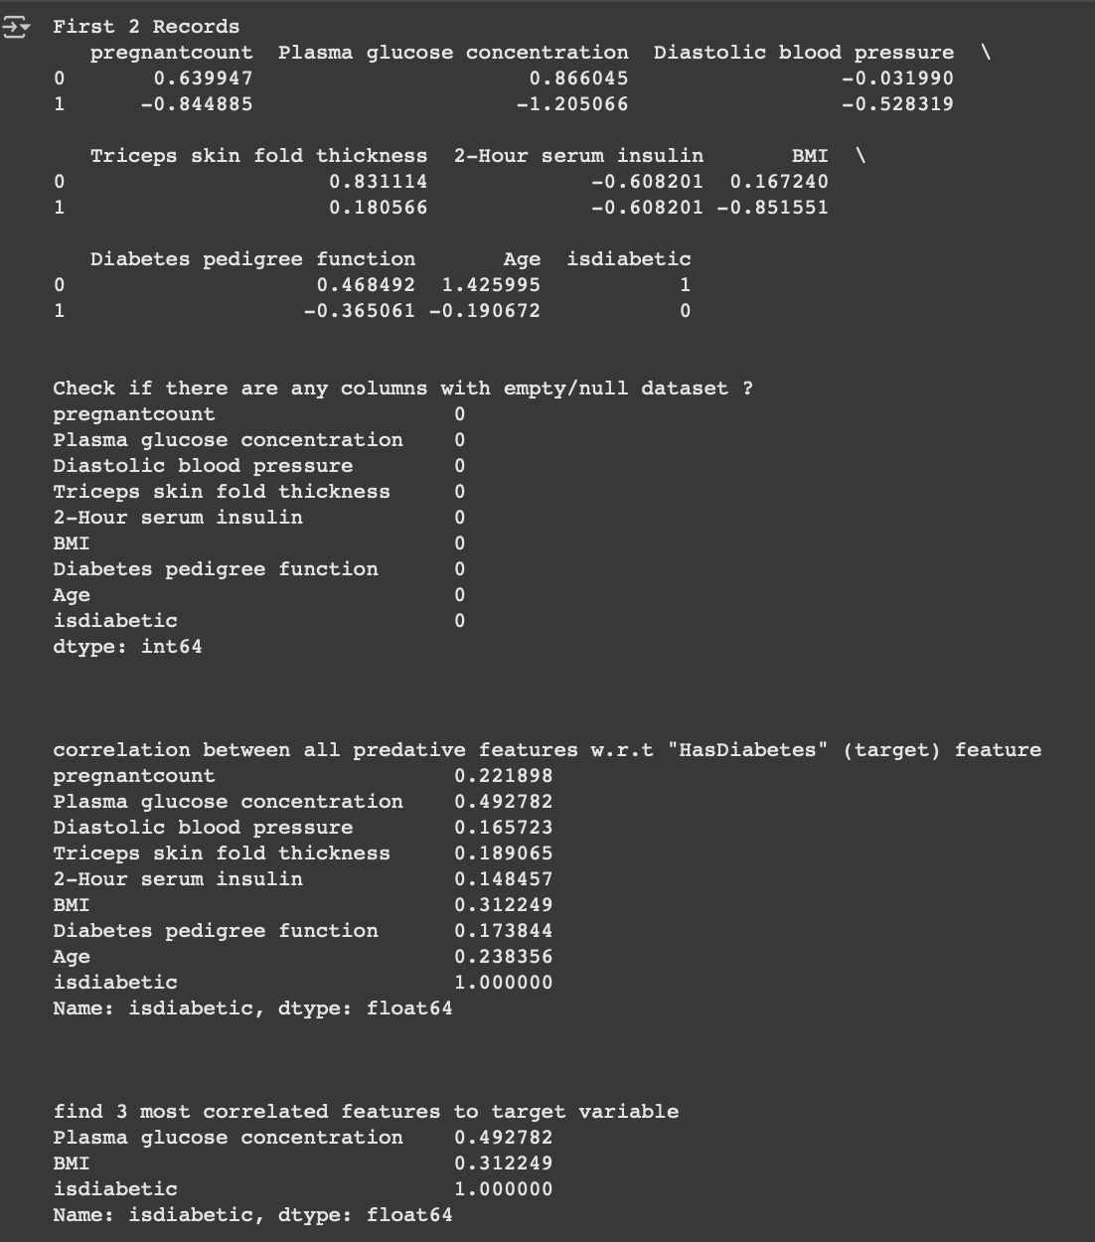
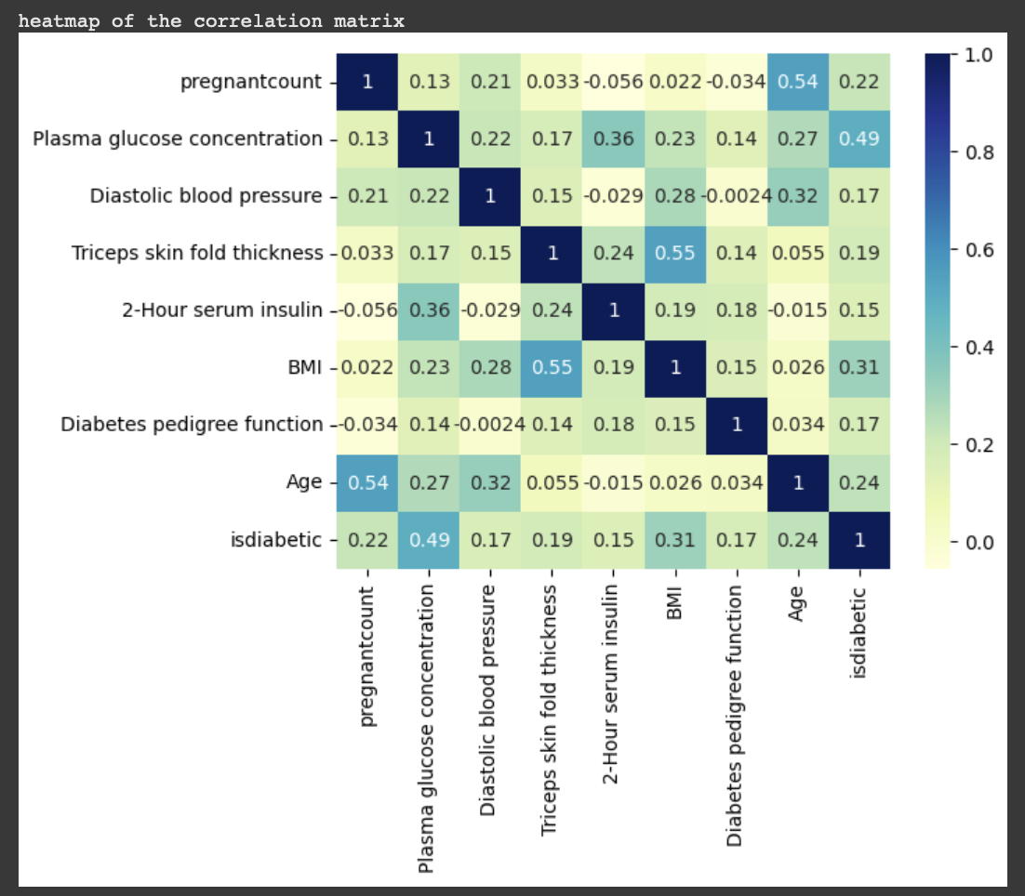

- Data cleaning and pre processing
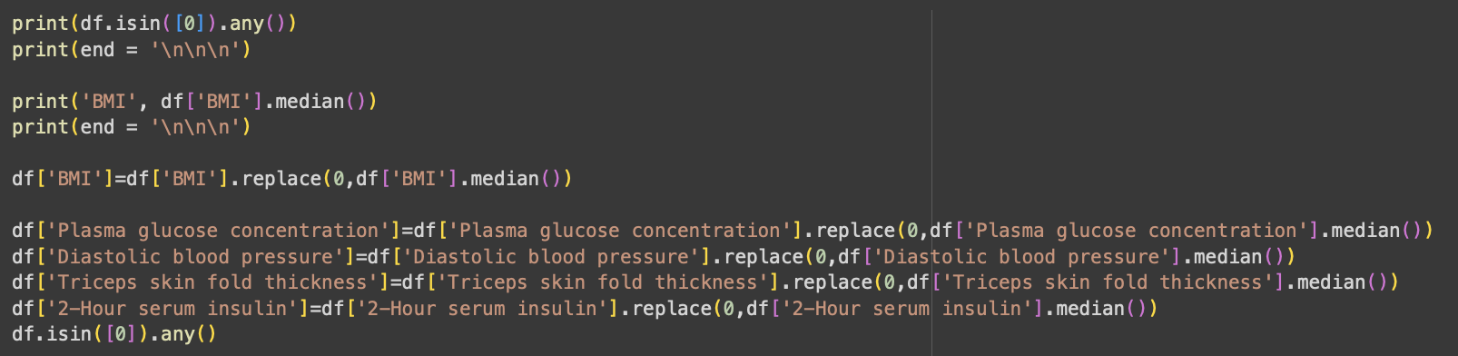
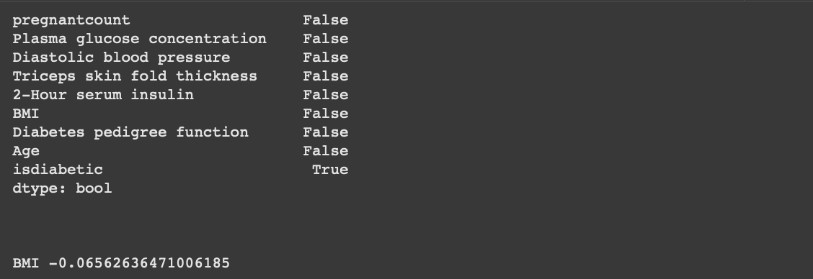
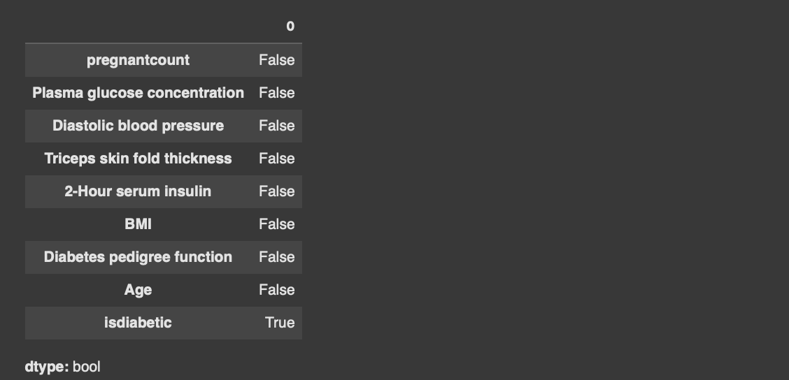
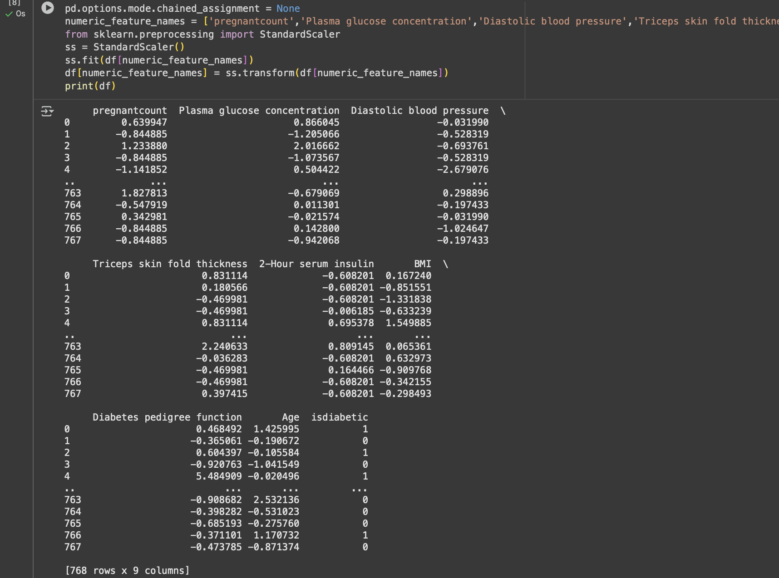

- Compare the accuracy
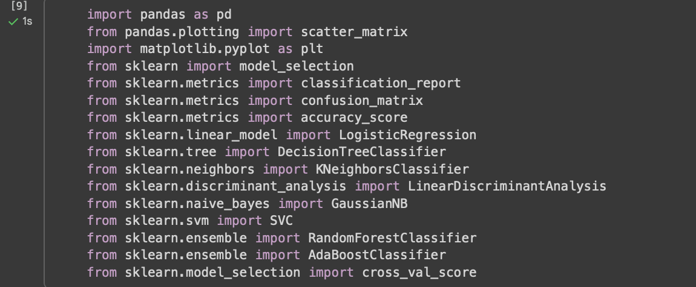
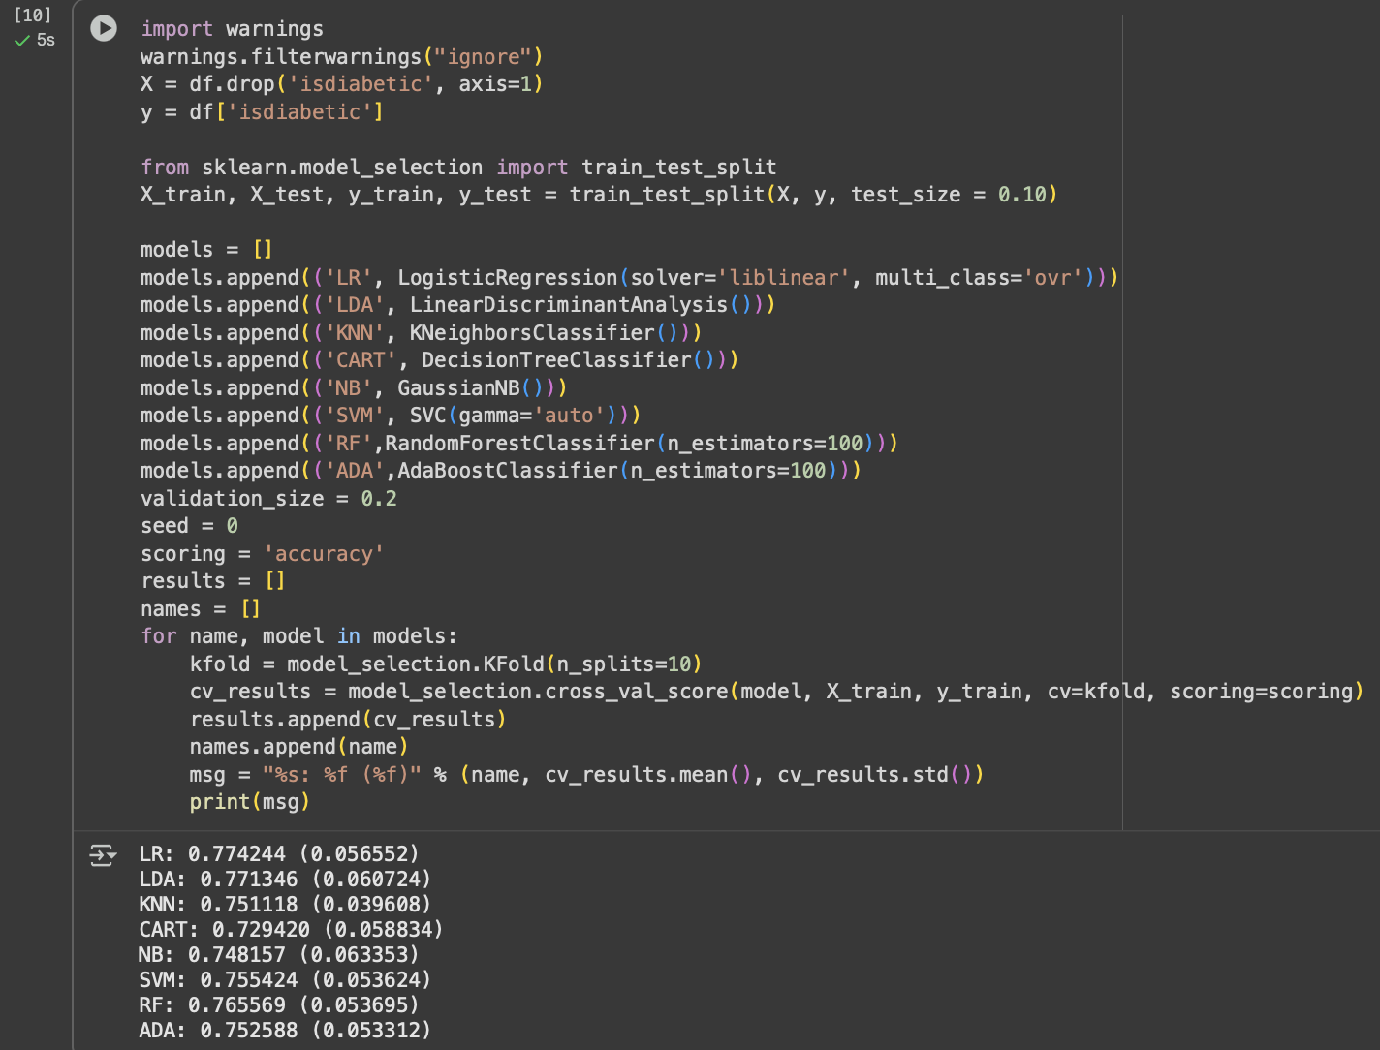
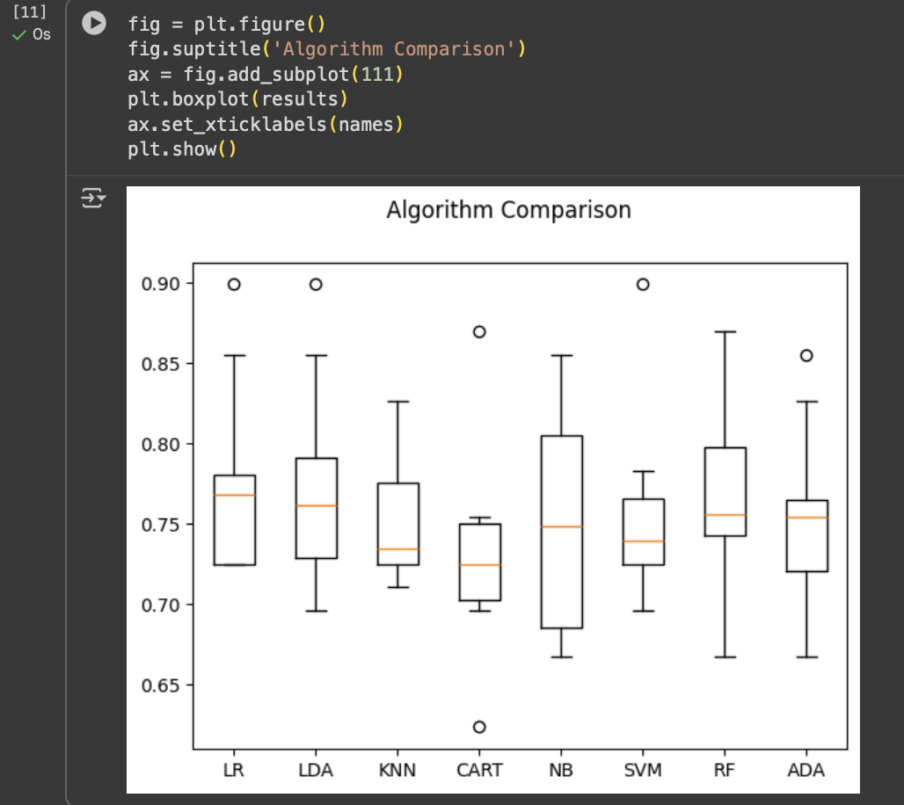
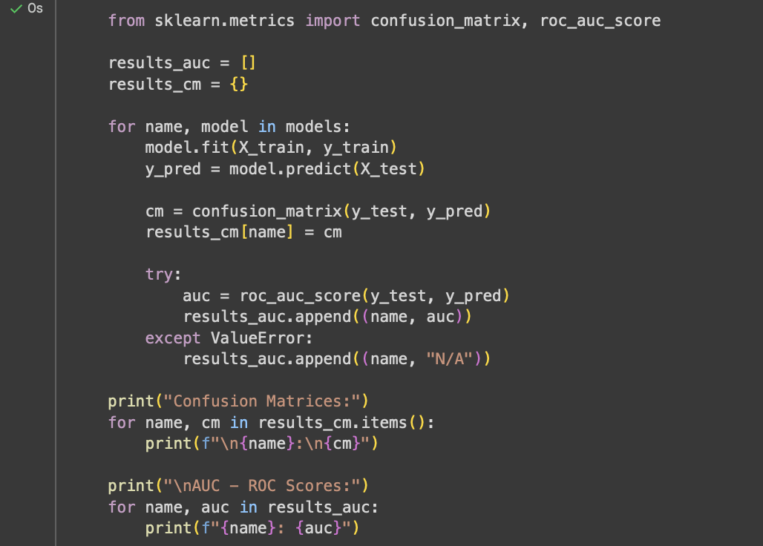
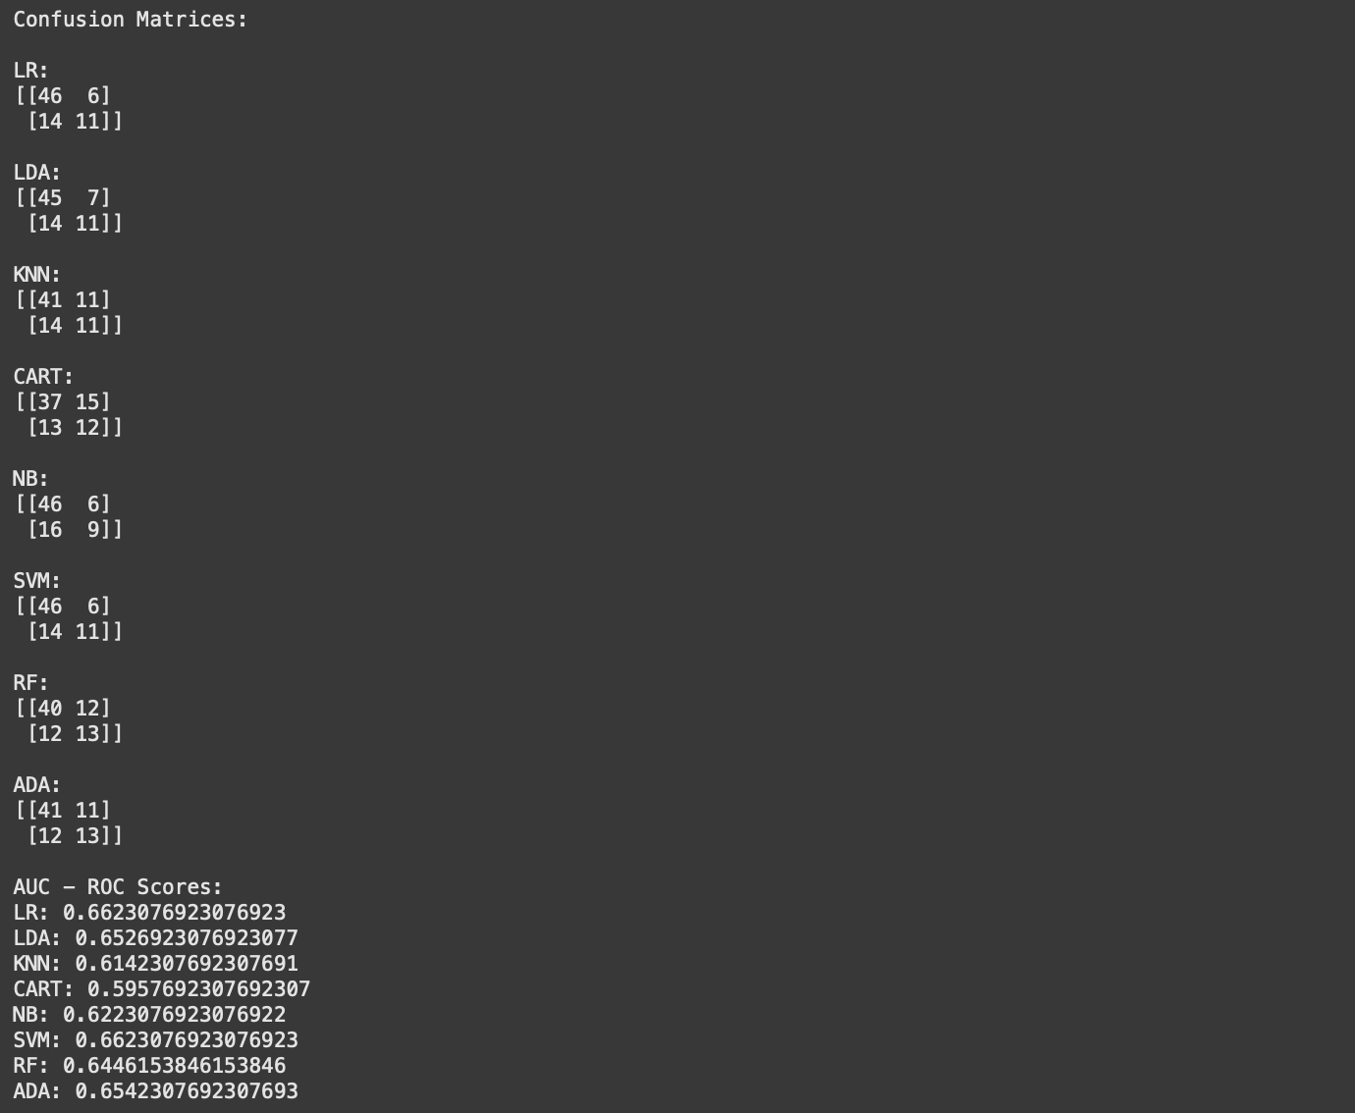

8.8 Conclusion:
From this experiment, we understood how to build and evaluate predictive models using AdaBoost and Random Forest algorithms. We learned how ensemble methods improve model accuracy by combining multiple learners and how evaluation metrics like confusion matrix and ROC-AUC help in assessing model performance. This experiment demonstrated the importance of preprocessing and comparative model analysis in real-world machine learning applications.

8.9 Questions:
- What is the difference between Bagging and Boosting?
Bagging trains multiple models independently on random data subsets and averages their results to reduce variance.
Boosting trains models sequentially, where each new model focuses on correcting the errors of the previous ones to reduce bias.

- Why is Random Forest less prone to overfitting than a single decision tree?
Random Forest combines predictions from many decision trees trained on random subsets of data and features, reducing the impact of noise and preventing overfitting.

- What role do weights play in AdaBoost?
In AdaBoost, weights determine the importance of each training sample — misclassified samples get higher weights so the next model focuses more on them.

- Define accuracy and ROC-AUC score.
Accuracy: The ratio of correctly predicted instances to the total instances.
ROC-AUC Score: Measures a model’s ability to distinguish between classes; higher AUC means better classification performance.

- Why is feature scaling necessary before model training?
Feature scaling ensures all features contribute equally by bringing them to a similar range, improving convergence and performance of algorithms like SVM, KNN, and gradient descent-based models.

